ENGG1340 Computer Programming II

COMP2113 Programming Technologies

Module 7 Checkpoint Exercise

Name: Wang Junshi

University ID: 3035638624

Instructions:

For each single question or each group of questions in the Checkpoint exercise, please type your answer right after the question in this Word document.

**Checkpoint 7.1 (Please submit your answer to Moodle)**

There may be error(s) in the following statement. Correct the error(s) if any, if no error, please write “no error”.

ofstream cfile;

cfile.open (c.txt, ios::ate, ios::binary); [Assuming the file c.txt exists.]

Ans: the correct one shoule be

ofstream cfile;

cfile.open(“c.txt”,ios::ate|ios::binary);

**Checkpoint 7.2 (Please submit your answer to Moodle)**

LeetCode is a popular and famous platform and community among developers over the world. It is a well-developed platform for challenging yourselves on coding skills as well as practising and preparing for interviews for the Tech Giant companies like Google, Microsoft, Facebook, etc.

Visit https://leetcode.com/ and register for an account by clicking “Create account” (Fig. 1). You may see the page of account sign up for registering your account (Fig. 2).



Figure 1

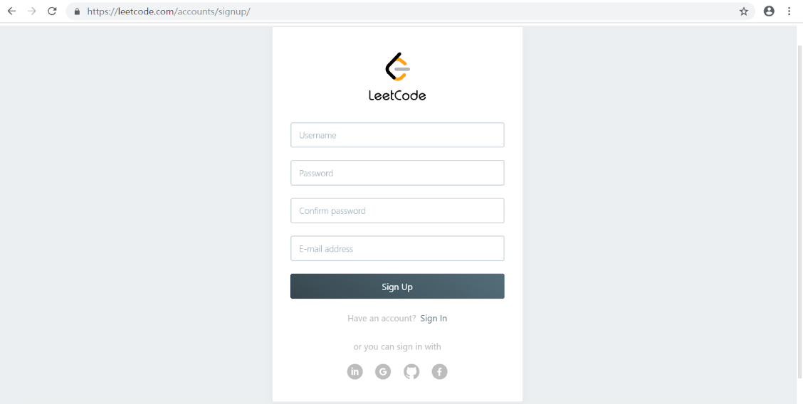

Figure 2

After successful signup, please log in. You should be able to see the following page after login (Fig. 3). Choose Problem #1 (Title: Two Sum), and you will be brought to the problem description and a VPL-like online coding environment (Fig. 4).

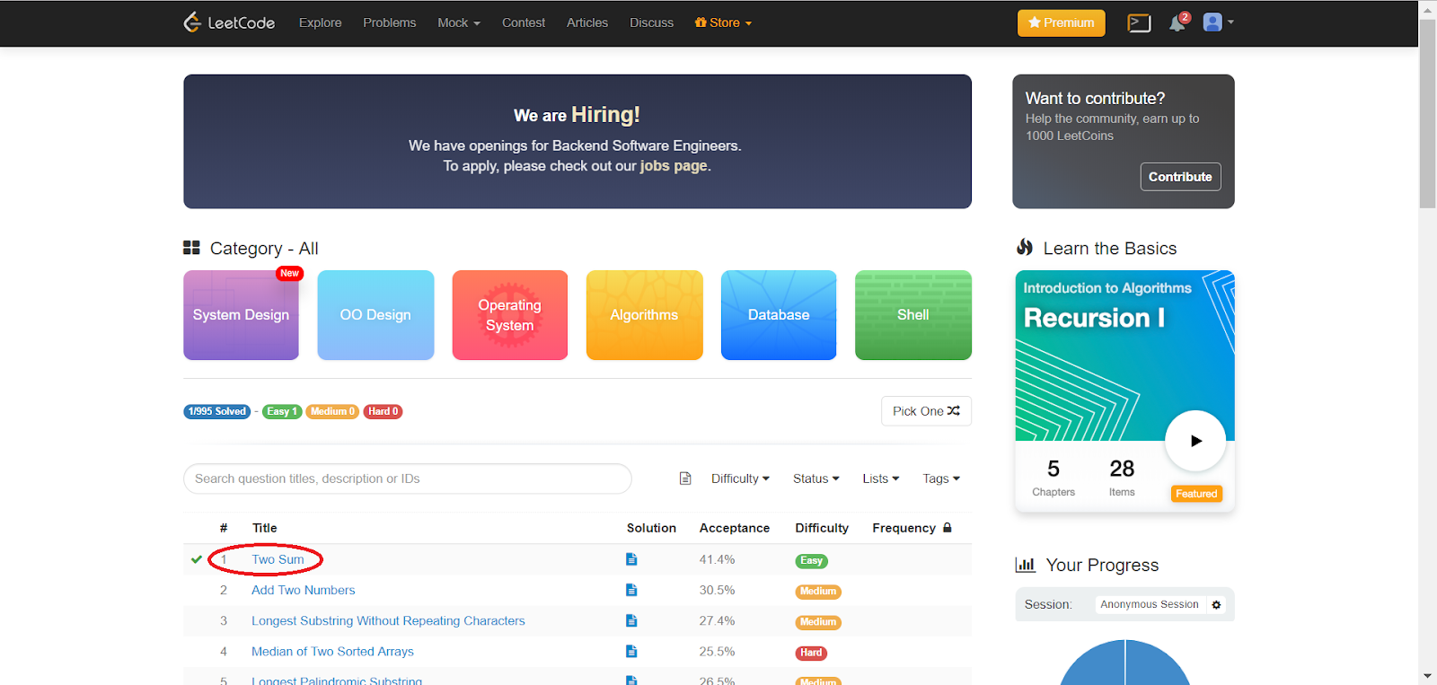

Figure 3

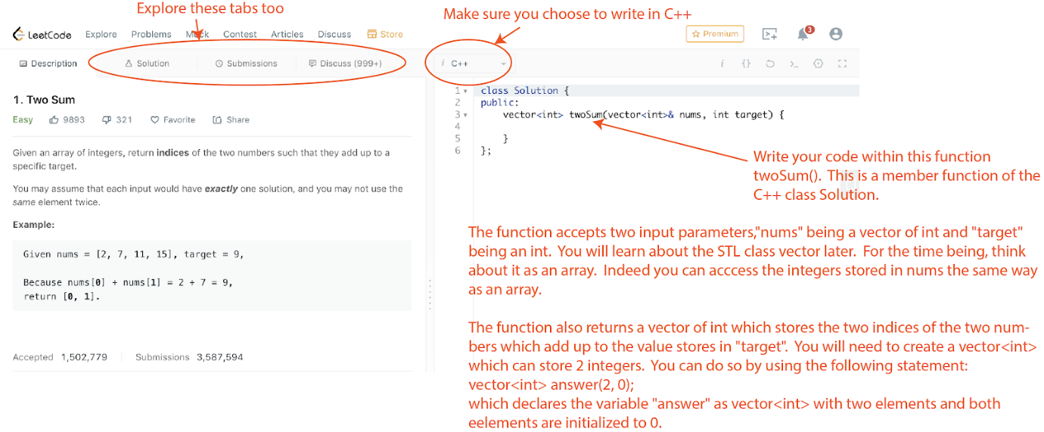

Figure 4

Explore also the tabs “Solution”, “Submissions” and “Discuss”.  In particular, under “Submission”, you will be able to find the information of your submissions (Fig. 5).

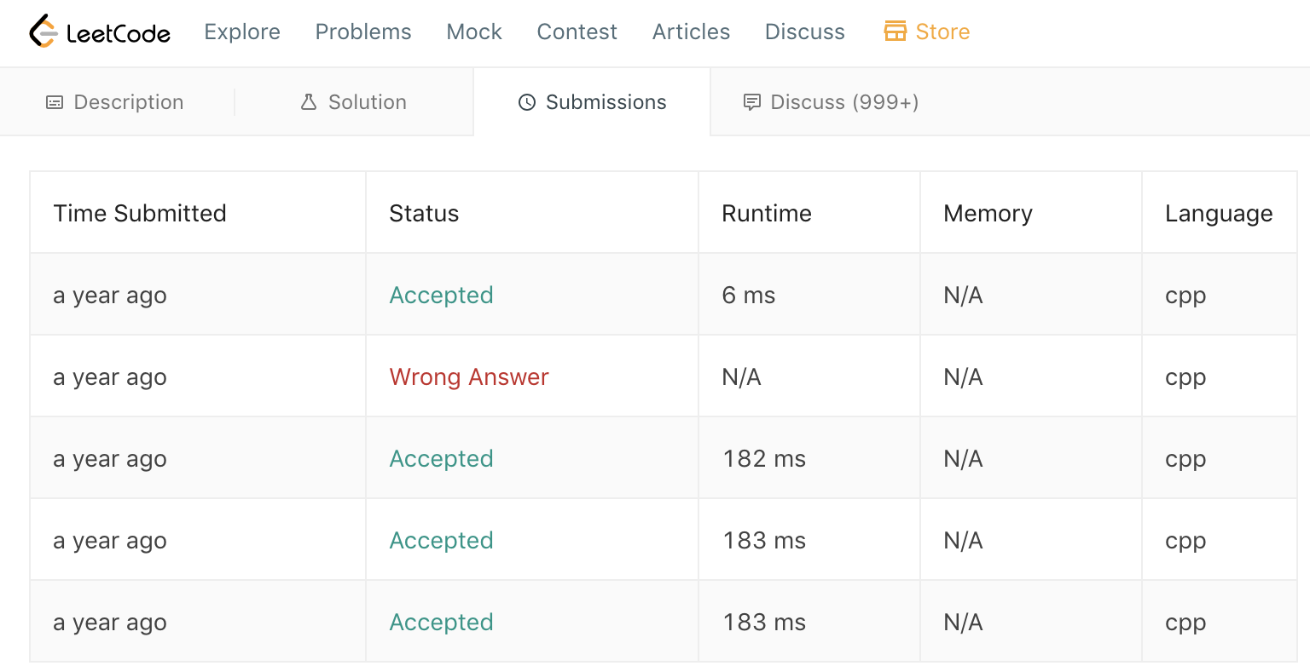

Figure 5

When you click on the status of each submission, you will be able to see the runtime (i.e., how fast your solution is) and the memory consumption.  Also, you can see how your solution is ranked among other submission from all over the world in terms of runtime (Fig. 6). You can keep improving your solution in order to beat others!

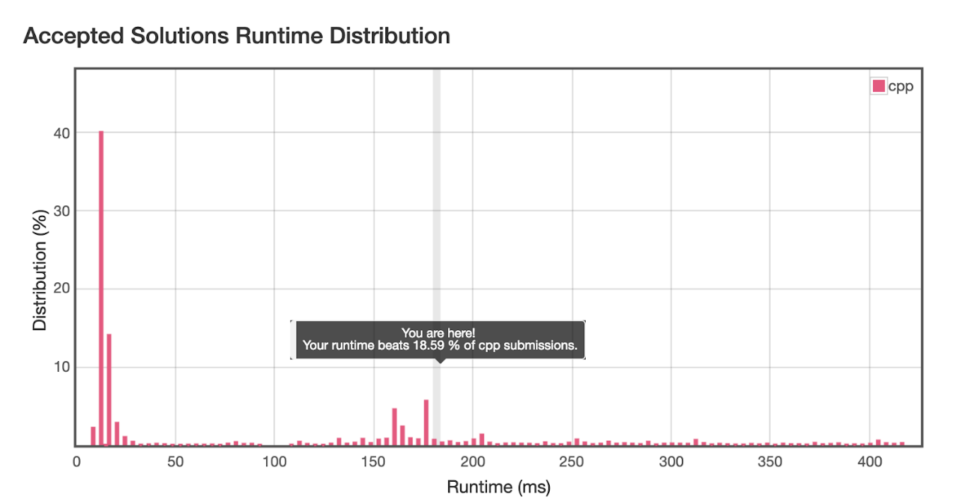

Figure 6

**Please complete Problem #1 (Title: Two Sum) and provide a screen capture (similar to that in Fig. 5) for your submission.**

An example (vectorcode.cpp) for simple usage of vector is included for your reference.

